Name: ________________________________________ Arr: _________

Chapter 22 Written Problems Worksheet

**Use this sheet to record your answers to the following Chapter 22 Challenge Problems.**

1. Identify which of the Teensy 3.2’s signal pins are analog pins and which are digital pins.
2. Study the following algorithm and examine the possible outputs on the right. Which output is *possible*? There may be more than one answer.

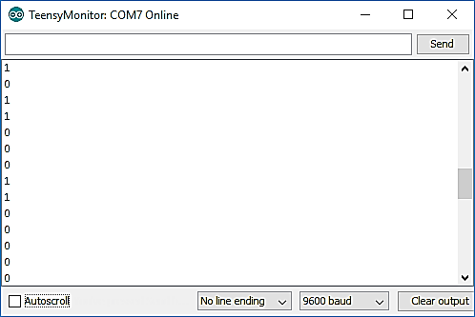

**Output A**

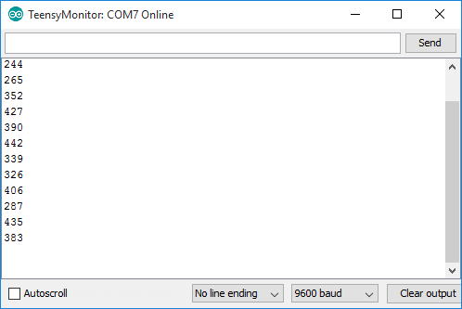

**Output B**

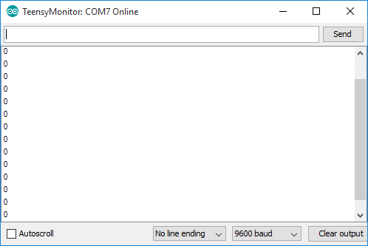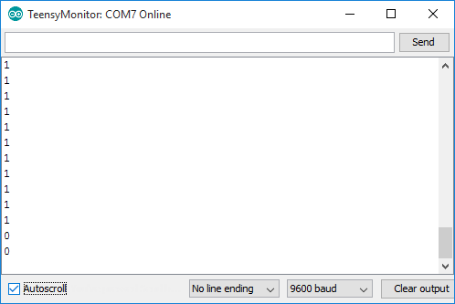

**Output C**

**Output D**

// globals

const byte sensorPin = 14;

void setup() {

pinMode(sensorPin, INPUT);

}

void loop() {

int sensor = digitalRead(sensorPin);

Serial.println(sensor);

delay(150);

}

1. Study the following algorithm and examine the possible outputs on the right. Which output is *possible*? There may be more than one answer.



**Output A**

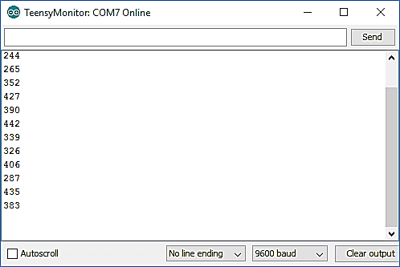

**Output B**

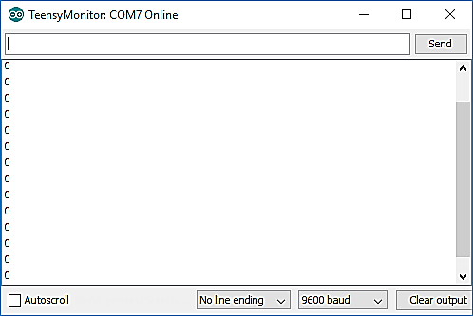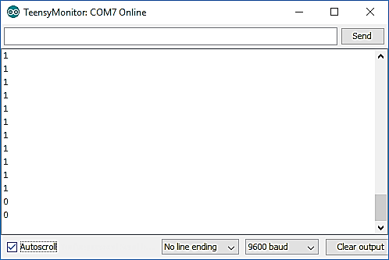

**Output C**

**Output D**

// globals

const byte sensorPin = 14;

void setup() {

pinMode(sensorPin, INPUT);

}

void loop() {

int sensor = analogRead(sensorPin);

Serial.println(sensor);

delay(150);

}

1. The HC-SR04 ultrasonic sensor must be driven with what voltage? Give your answer in volt units.
2. Study the following chunk of code that is intended to set up an ultrasonic sensor for use with a microcontroller. Fill in the blanks with the appropriate Arduino keyword.

// globals

const byte trigPin = 11; // trigger pin for ultrasonic sensor

const byte echoPin = 12; // echo pin for ultrasonic sensor

void setup() {

pinMode(trigPin, ______________________);

pinMode(echoPin, ______________________);

}

1. Study the following algorithm and find the **two mistakes** in the code. Assume that a brand new SR04 ultrasonic sensor is properly connected to PRT3. The sketch compiles and uploads just fine, but the sensor does not respond appropriately when a solid object is placed within its ultrasonic beam. What are the mistakes in the code?

// globals

const byte trigPin = 11; // trigger pin for ultrasonic sensor

const byte echoPin = 12; // echo pin for ultrasonic sensor

void setup() {

pinMode(trigPin, INPUT); // set the pinMode for the trigger pin

pinMode(echoPin, OUTPUT); // set the pinMode for the echo pin

}

void loop() {

// create the trigger pulse to initiate range measurement:

digitalWrite(trigPin, LOW);

delayMicroseconds(1500); // delay to prevent over-sampling

digitalWrite(trigPin, HIGH);

delayMicroseconds(10); // 10us is the minimum trigger pulse width

digitalWrite(trigPin, LOW);

// grab the pulse width from echo pin and print it to the screen:

long echoWidth = pulseIn(echoPin, HIGH, 10000);

Serial.println("Round-trip time = " + String(echoWidth) + " us");

}

1. The following are pulses from the echo pins of three ultrasonic sensors. All three sensors detect objects. Which sensor detected the closest object? Which one detected the object with the greatest distance?

**Sensor #1 Echo**

**Sensor #2 Echo**

**Sensor #3 Echo**

1. The following is a pulse from the echo pin of an SR04 ultrasonic sensor. Its pulse width is measured to be 6430µs, as shown in the figure below. Calculate the distance to the object in **centimeters**. Use the appropriate speed of sound value from Table 22.1 on page 840 in your calculations

**Echo Data**

6430µs

1. Imagine the trigger pin of your SR04 ultrasonic sensor is plugged into Teensy pin 8 and the code to generate the trigger pulse is created by the three algorithms below. Match the algorithm to the appropriate trigger pulse graphs.

**Trigger Pulse A**

**Trigger Pulse B**

**Trigger Pulse C**

**Algorithm #1**

digitalWrite(8, LOW);

delayMicroseconds(10);

digitalWrite(8, HIGH);

delayMicroseconds(10);

digitalWrite(8, LOW);

**Algorithm #2**

**digitalWrite(8, LOW);**

**delayMicroseconds(10);**

**digitalWrite(8, HIGH);**

**delayMicroseconds(30);**

**digitalWrite(8, LOW);**

**Algorithm #3**

**digitalWrite(8, LOW);**

**delayMicroseconds(30);**

**digitalWrite(8, HIGH);**

**delayMicroseconds(20);**

**digitalWrite(8, LOW);**

**Algorithm # _______**

**Algorithm # _______**

**Algorithm # _______**

1. Imagine the echo pin of your SR04 ultrasonic sensor is plugged into Teensy pin 9 and you wish to listen for the round-trip echo for 2000µs. The code to listen for the echo is given below. Fill in the blanks with the appropriate values.

long echoWidth = **pulseIn**(________,________,________)

1. What is the maximum distance that the sensor in the previous problem can measure?

**Turn in this sheet to be graded.**